Discover the wild side of Nepal with Meghauli Serai

~ Meghauli Serai Jungle Lodge by Taj Safaris opens in Chitwan National Park ~
Mumbai, April 4, 2016: Taj Safaris, the creators of India’s first luxury wildlife travel circuit in Madhya Pradesh, today announced the opening of its first lodge outside India: Meghauli Serai at UNESCO World Heritage listed Chitwan National Park, Nepal. Taj Safaris has signed a management contract for Meghauli Serai with owners CG Hotels and Resorts, a leading Asian hospitality group.
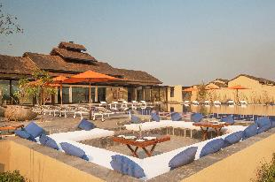
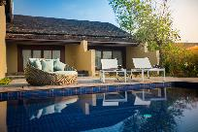
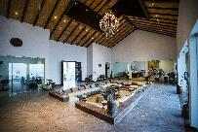

The jungle jewel of an ancient kingdom
In a land of snow peaks and sherpas, yaks and yetis, monasteries and mantras,where ancient temples, shrines, palaces and monuments offer a glimpse into the past, Chitwan National Park is a real jewel. Its dramatic landscapes of dense Sal groves, thick grasslands and meandering water bodies, coupled with the breathtaking wildlife, make it one of the most sought after destinations in Nepal. From its prime position nnestled on the banks of the Rapti river, Meghauli Serai offers spectacular views of the park across the river from its 30 rooms and suites.

Chitwan National Park is home to an astounding550native bird species, including the Great Hornbill, Ruddy Shelduck and Pied Kingfisher, and approximately 68 species of mammals. The majestic Royal Bengal tiger, leopards, wild dogs and sloth bears are in abundance in this natural paradise, but the park’s main attraction is the GreaterOne-horned Rhinoceros. With its armour-like body plates and a solitary horn, the rhino isthe Park’s local celebrity.

Rohit Khosla, Sr. Vice President – Operations, Taj Hotels Resorts and Palaces said: “We are delighted to extend the legendary Taj hospitality to guests in Nepal. The Taj grouphas a pioneering reputation for creating destinations and we are very proud to present the latest Taj Safaris’ Meghauli Serai Jungle Lodge at Chitwan National Park. We are committed to adding value to the community and the region.”

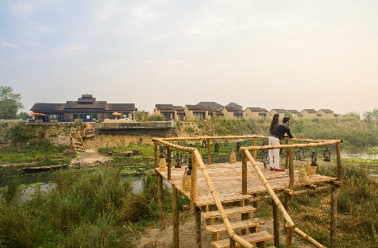
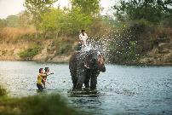

Local meets luxury at Meghauli Serai
From its 13 well-appointedrooms that offer elevated views over the jungle-scape to the 16 independent villas each with their own private plunge pools and the plush Rapti Mahal presidential suite, the lodge takes local traditions to a luxurious setting. Meghauli Serai has incorporated local hues into its design and operations for truly sustainable touches.From its Newari and Tharu-inspired front doorsand the use ofnatural earthy tones thatreflect the landscape,to the locally-sourced ingredients that foreground Tharu tastes in inventive cuisine, the lodge offers a relaxing setting for discovery.

Interpretive wildlife experiences allow guests to discover and enjoy the stunning natural beauty of Nepal. Safaris on elephant-back, by jeep and jungle walksgive a whole new perspective on jungle life. Walks through the local Tharu village showcase traditional village life, where guests can learn the tricks of moonshining for traditional brews or get a taste of fresh homemade Nepalese pickle. Canoeing on the Rapti river or trekking through the awe-inspiring Himalayan foothills will satisfy the adventure-seekers. When it’s time to relax, nowhere is more suitable than with the signature spa treatments or by the cool water of the infinity pool, overlooking the tranquil flow of the Rapti river.

Mridula Tangirala, Director of Operations at Taj Safaris said: “Taj Safaris believes that the best wildlife experience is interpretive and rooted in the local wildlife and community through a proven sustainable ecotourism model. Our four luxury jungle safari lodges in Madhya Pradesh’s tiger country created India’s first luxury wildlife travel circuit. With this exciting opening in Nepal, we are looking forward to welcoming guests for immersive wildlife experiences in the ‘heart of the jungle’ at our newest destination, Meghauli Serai.”

Getting there
Meghauli is easily accessible from Kathmandu by road or by flight. It takes a short 20minute flight from Kathmandu to Bharatpur airport, followed by a 45 minute or 30 kms drive to Meghauli Serai Jungle Lodge in Chitwan National Park.

An alternative is to take a private charter from Tribhuvan International Airport in Kathmandu, to the Meghauli Airstrip in Chitwan. Helicopter charters are also available from Kathmandu to Meghauli Serai Jungle Lodge.

About Taj Safaris

Breaking new ground in India, a joint venture between Taj Hotels, Resorts and Palaces, CG Hotels & Resorts, and &Beyond offers India’s first and only wildlife circuit. This partnership, known as Taj Safaris, provides guests with the ultimate interpretive wildlife experience, based on a proven sustainable ecotourism model. & Beyond's collaboration with Taj Hotels rests on decades of expertise in operating luxury jungle safari lodges offering unique wildlife experiences, coupled with legendary service in hospitality. The first lodge in this circuit, MahuaKothi, opened for guests on 1st November 2006; after which three more lodges were added to the portfolio, Baghvan—Pench National Park, PashanGarh – Panna National Park and Banjaar Tola – Kanha National Park, which completed the tiger circuit on 18th February 2009.
About CG Hotels & Resorts
CG Corp Global is a transnational conglomerate with an exceptional legacy of 150 years. Present in over 30 countries with 76 brands, 80 companies and with an employee base of 10,000 people, it is Nepal's first and only Billion Dollar corporation that produces world class products, brands and services. The Group’s notable areas of interests are FMCG, hospitality, finance, banking, cement, real estate, electronics, telecom, education, energy, biotech, power, and retail to name a few.
Its hospitality arm, CG Hotels & Resorts is an Asian hospitality chain comprising 4411 keys, 79 hotels in 59 destinations across 12 countries including its own Zinc & Fern branded hotels and resorts. CG Hotels & Resorts also has a proud history of successful joint ventures and investments with esteemed partners and brands such as Taj, Alila, Jetwing, The Farm amongst others. It's diverse and unique portfolio of owned and partner hotels under these brands include acclaimed properties such as the iconic Taj Exotica Resort & Spa Maldives, Taj Samudra Colombo, The Farm in Philippines, JetwingVilUyana in Sigiriya Sri Lanka and Taj Safari lodges in central India. With the newest addition of ‘Meghauli Serai Chitwan’ under Taj Safaris (A JV with Taj), CG Hotels & Resorts continues to provide world class hospitality services making it one of the most diversified hospitality groups in the region.

